**IFT 466 Advanced Computer Networks**

**Lab 28  
Quality of Service (QoS) – Implementation**

**Objective**Implement Quality of Service (QoS) in network topology

In lab 26 you watched how to setup QoS on a specific network topology.

In this lab, you will implement QoS on a topology of your choosing.

You just need to demonstrate one QoS concept.

You can any piece of software as part of your implementation.

You need to provide the topology and the series of steps/commands to setup QoS on the topology.

**STEP 1**: I’m implementing the following topology. I have configured each of them with the Ip’s as specified in the picture.

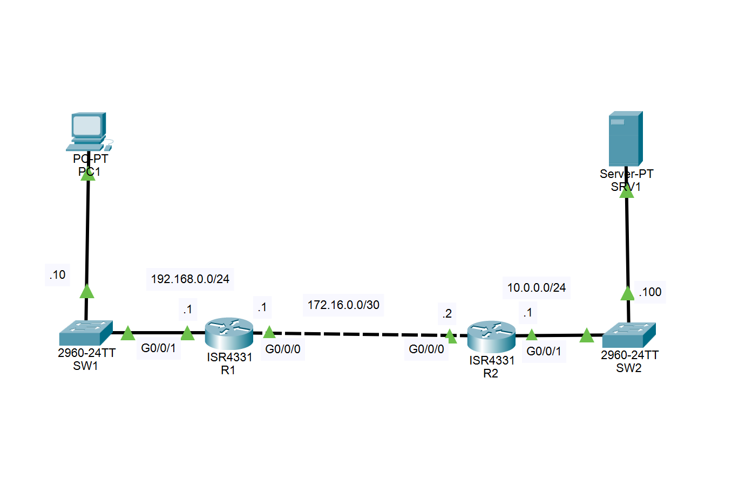

**STEP 2**: Now I’ll configure QoS on R1. The commands are show below.

**First step** of QoS configuration: setup **class maps**. Which identify the types of config you want to apply special traffic to.

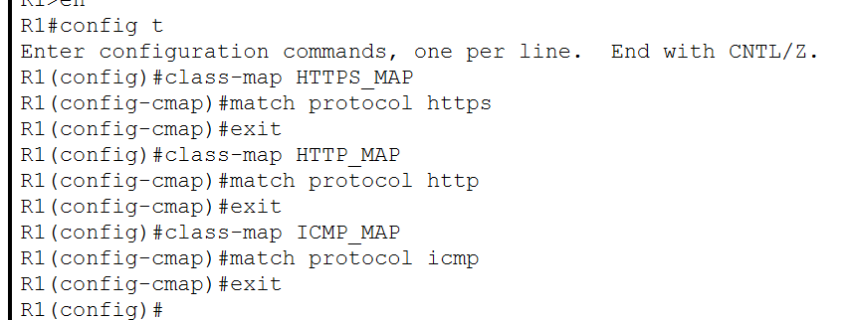

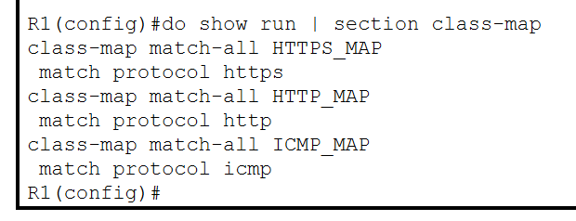

**Second step**: We need to identify what kind of treatment we want to give to each kind of traffic. For this we use **policy maps**.

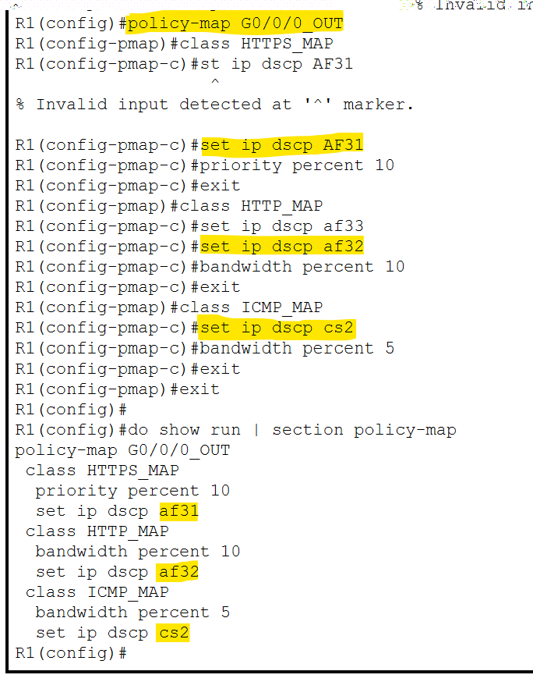

Here, I have assigned 10 percent priority bandwidth to HTTPS and HTTP traffic. And 5 percent bandwidth to ICMP traffic. All other traffic does not have any priority bandwidth assigned.

**Third step:** Now, I will apply this policy by using **service policy**.

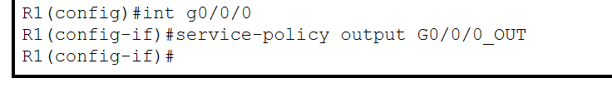

**Final Step:** Now, Verify it using the “Show running-config” command

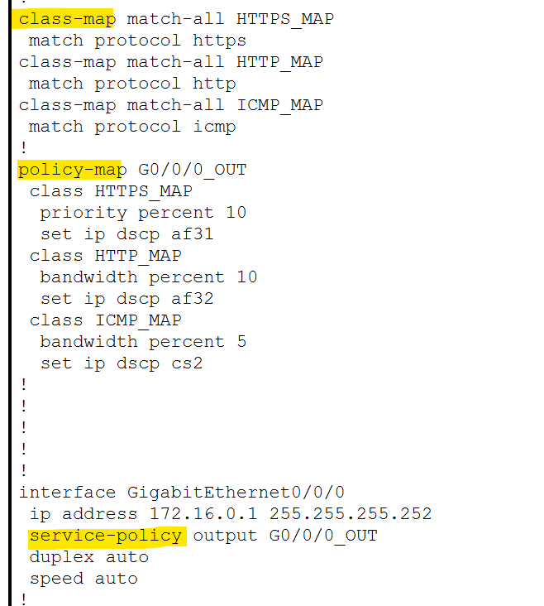

**STEP 3:**

Ping and verify the DSCP connection.

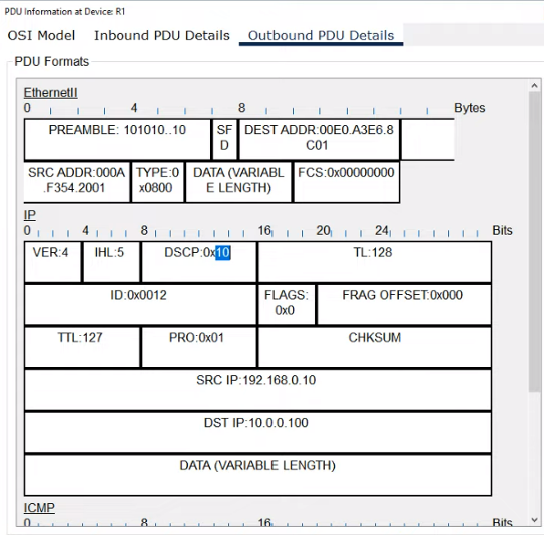

**STEP 4:** Now lets send HTTP traffic from PC1 to server.

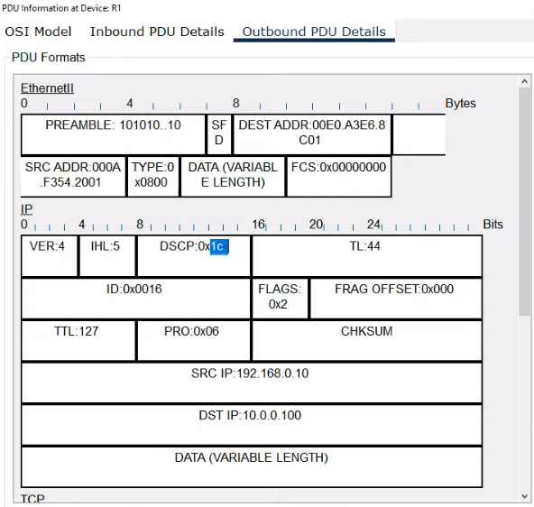

**STEP 5:** Now lets send HTTPS traffic from PC1 to server.

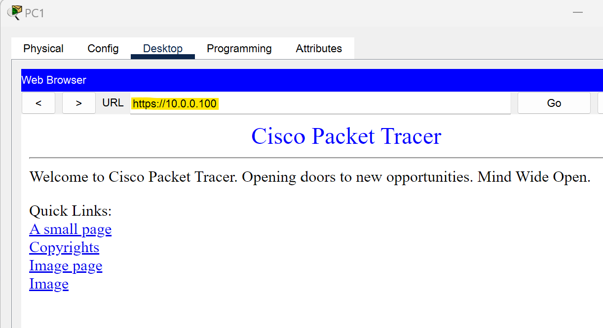

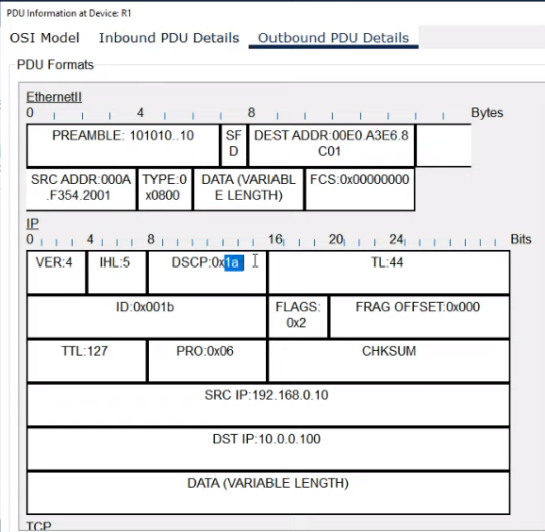

In steps 3, 4 and 5 we observed QoS working by sending different kind of traffic each time.